Video Storyboard- Appraisal Video
GFX= graphics

Block | Audio/ Text | Video
001 | Orange County, North Carolina  What is Market Value? | 
002 | Market value is how much a property would sell for in the open market under normal sale conditions. | 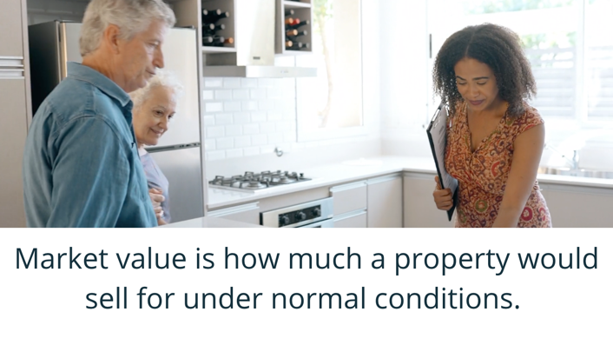
003x | This does not include sales where the buyer or seller is under pressure to act, perhaps due to career relocation, death of a family member, or divorce. | 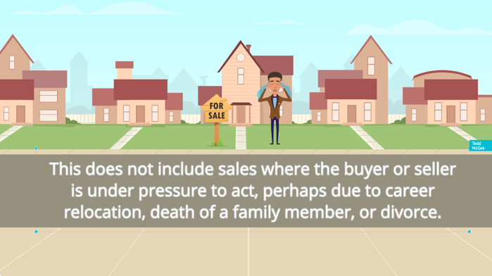
004x | North Carolina law requires counties to value property at 100% of Market Value, which may be higher or lower than the actual sales price for a property. | 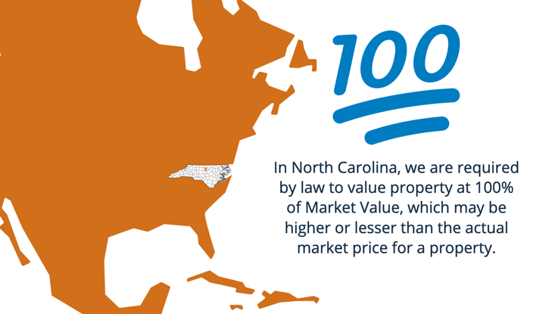
005 | How is my property value being determined? | 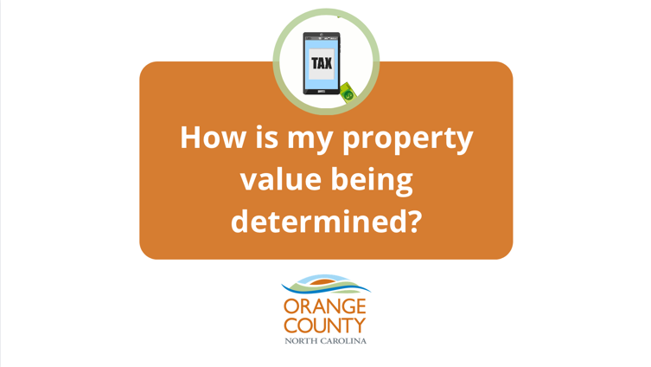
006 | Orange County staff appraisers use various tools to help determine the fair market value of all properties in the county. Some of these tools have a public version on our website. | 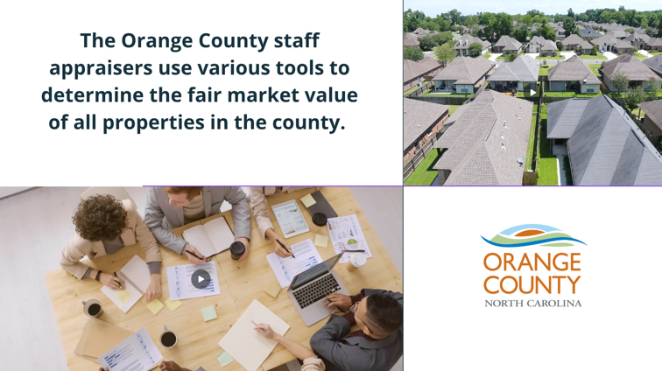
007 | One of the tools is called a “Property Record Card Search.” It allows property owners to review property information and request corrections online. | 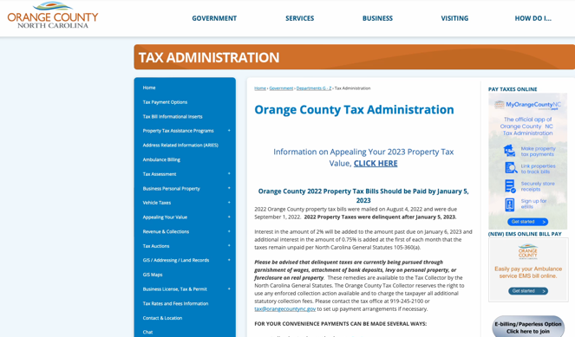  Screen recording of navigating to property record card search.
008 | A second publicly available tool is called “Orange Public Comper.” This allows anyone to search for comparable properties or “comps” in their neighborhood to determine an estimate of value for their own properties, as well as running a general sales report for the selected neighborhood or area. | 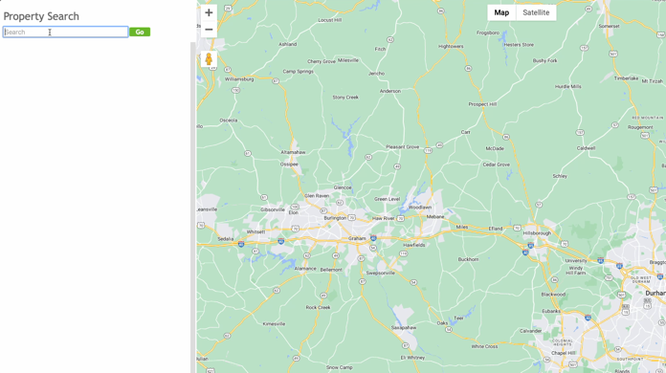  Screen recording of navigating to comper.
009 | Other tools used by the Tax Office to assist with the Revaluation include:  - cost manuals  - ratio studies  - revenue stamps  - sales files | 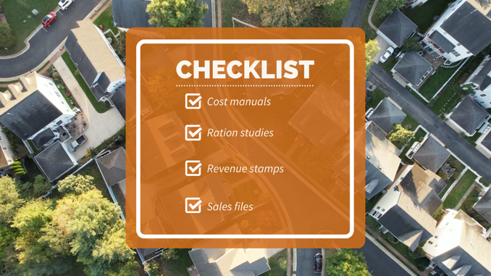
010 | This process makes sure that properties are valued fairly so the tax burden is distributed equitably among property owners. | 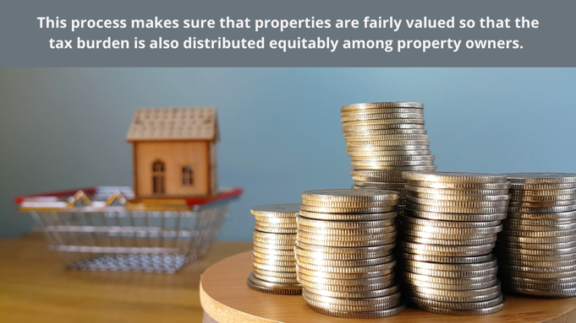
011 | End card/ Outro with contact info and QR codes to Property Report Card and Comper

