

AWARD CATEGORIES

Rising Star Award
Has been a caregiver for three years or less and already demonstrates enormous promise for the profession.

Client Impact Award
Frequently recognized or praised for their efforts that make an impact on the quality of their clients’ lives.
Going the Extra Mile Award Passionate about providing extraordinary care to their clients in ways that exceed expectations.

Leadership Award
Serves as a role model and demonstrates teamwork and a willingness to help other direct care workers and staff.

Longevity Award
Has performed outstanding work as a caregiver each year for the last 10 or more years and plans to continue working in the field.

Direct Care Worker of the Year Award
The Best of the Best. Outstanding in every area.

SHARP

DIRECT CARE WORKER AWARDS
Honoring nurse aides, personal care aides,
companions, senior living assistants, etc., who
have provided outstanding services to Orange
County residents over the past year.

November 13, 2025
4 – 6 p.m.

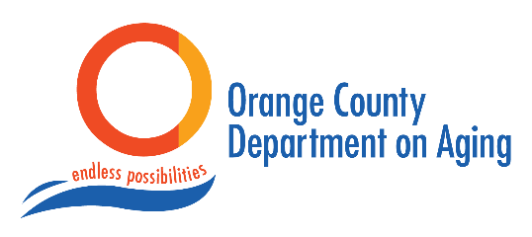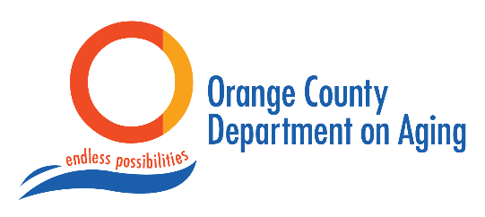

2025 Orange County Sharp Direct Care Worker Honor Roll

ORDER OF EVENTS

4:00 p.m. Welcome
Janice Tyler, Director
Orange County Department on Aging

Award Purpose
Heather Altman, Founding SHARP (Senior Health Advocacy & Resource Partners) Member
Jamezetta Bedford, Chair
Orange County Board of County Commissioners

Catherine Lee Rita Fellers Asmaa Abouam Loubna Selouane Touria Smie Teresa Noell Joanne Miller Ande Richardson Sabrina Miller Betty Richards

Alexandria Crisp Edith Hillard
Irene Jones
Kayla Kilcollins Nichole Soehner Teresa Afeku Brinley Stylons Mona Simmons
Sarah Buscher
Isabel Dominguez Ornelas
Anetra Boykin

Esther Lee
Jeslyn Lizbeth Camilo
Cierra White
Sean Ahaotu-Simelane
Jennifer Tinnen
Destiny Sanford
Ashia Singleton
Laranine Turner
Katie Love
Lajayanes Burnet
2025 Nominating Agencies

Honoree Slideshow

Rising Star Award

Longevity Award

Leadership Award

Going the Extra Mile Award

Client Impact Award

2025 Direct Care Worker of the Year

4:15 p.m. Award Announcements

Acorn Homecare Services
Always Best Care
CareYaya
Carol Woods Retirement Community
Homewatch Caregivers of the Triangle Charles House Association

Individual Family Caregivers
Premier Home Healthcare
Right at Home of the Triangle
Soltys Place
Transitions LifeCare
Thank you to our Donors for contributing to the Honoree Gift Bags

5:00 p.m. Closing Congratulations

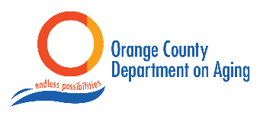

Acorn Homecare Services
All About Seniors
AuthoraCare Collective
Carol Woods Retirement Community
Dignified Living
Harmony Advisors
Homewatch Caregivers of the Triangle
Piedmont Health
Orange County Department on Aging
Right at Home of the Triangle
Soltys Place

